# [Mariska Hargitay, Mehcad Brooks reveal story behind ‘Law & Order’ set pics](https://www.today.com/popculture/tv/mariska-hargitay-mehcad-brooks-reveal-story-law-order-set-pics-rcna48488)

"It’s like acting with a superhero," Hargitay said about working with Brooks on the upcoming "Law & Order" crossover premiere.

Sept. 21, 2022, 2:18 PM -03 / Source: TODAY

By MC Suhocki

["Law & Order: SVU" star Mariska Hargitay](https://www.today.com/popculture/tv/mariska-hargitay-importance-svu-addressing-olivia-bensons-trauma-rcna48495) flipped the script when it came to welcoming "Law & Order" newcomer Mehcad Brooks with open arms by quite literally jumping into his arms.

The two were filming together in New York City in August for the ["Law & Order" franchise's three-way crossover premiere](https://www.today.com/popculture/tv/law-order-brings-3-casts-together-first-time-historic-crossover-rcna44435), which airs Sept. 22.

Photos and [video](https://twitter.com/darveypaulsen/status/1560761675837472768?s=20&t=Npuc_DhzG-NnndLJOfy9YQ) of Hargitay running and jumping into Brooks' arms went viral among the fans at the time, and at the Sept. 19 "Law & Order" premiere red carpet event, TODAY asked the two actors for the story behind the moment.

Welcome to the "Law & Order" universe, Mehcad!Jose Perez/Bauer-Griffin / GC Images

Before becoming Detective Jalen Shaw in the upcoming season of "Law & Order," Brooks [guest-starred on "SVU"](https://www.today.com/popculture/remember-when-these-celebrities-guest-starred-law-order-svu-t107917) in 2011. He told TODAY he and Hargitay "hit it off at that moment."

"So, Mariska is the kind of person — I told her that my brother is the biggest 'SVU' fan in the world," Brooks explained.

He said Hargitay asked him for his brother's number, and a few months later, the "SVU" icon called Brooks' brother "out of the blue" and talked to him for about 15 minutes.

"My brother is going to remember that the rest of his life, and so that's who she is," Brooks said. "She's a legend in our house."

The former "Supergirl" star is a "superhero" in Hargitay's eyes.Jose Perez/Bauer-Griffin / GC Images

Fast-forward to 2022 when Brooks was telling Hargitay that story.

"She's like, 'Oh, that's so sweet. I remember that actually.' She's like, 'When I get to know you better, I'm just going to run up to you and just jump in your arms,'" he recalled.

"I go, 'Do it now,'" Brooks said. "She goes, 'Really?' I go, 'Do it now.' And she goes, 'OK.'"

He added she jumped into his arms between takes while filming.

"We were just kind of walking down the street, and she just — we did the 'Dirty Dancing' thing."

Hargitay said Brooks is "this just amazing specimen" who "looks like a superhero."

"Every time I see him I'm just like I just want to run into his arms and have him hold me because, because he can. And so, I was like, 'Can I come and jump in your arms?' And he's like, 'Sure,'" she explained while laughing.

"But it's like acting with a superhero. He's so much fun and so kind and so sweet, and it's really been a joy to get to know him," Hargitay said, before recalling Brooks' previous guest appearance on "SVU."

Legends only.Jose Perez/Bauer-Griffin / GC Images

Brooks not only filmed with Hargitay recently, but with another "Law & Order" staple: [Chris Meloni](https://www.today.com/popculture/tv/chris-meloni-carries-mariska-hargitay-back-emmys-photo-rcna47787).

Since both Brooks and Meloni are [extremely fit](https://www.today.com/popculture/popculture/chris-meloni-peloton-ad-rcna38274), we had to ask both men who would win an arm-wrestling contest between the two.

Meloni immediately responded he would not beat Brooks.

"I tried arm wrestling early on, and a) I don't have the technique slash skill set, and he's a pretty big man."

"That's nice of him," Brooks said after hearing Meloni's response. "Honestly, because Chris is so intense and he's so competitive, I think he might get me."

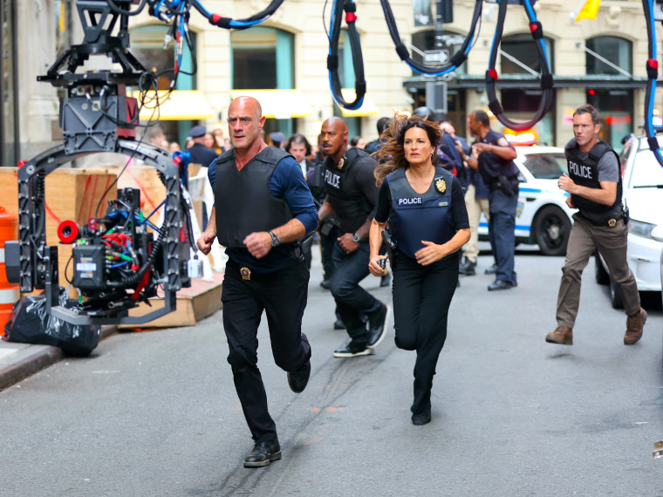Christopher Meloni, Mariska Hargitay, Mehcad Brooks and Jeffrey Donovan are seen on the set of "Law and Order: Special Victims Unit" on Aug. 18, 2022, in New York.Jose Perez/Bauer-Griffin / GC Images

"He would give me a run for my money in a way that I was not expecting," Brooks added. "For sure."

As for working with both Hargitay and Meloni, Brooks said, "I'm a student of life, and when you're just surrounded by legends, it would be a missed opportunity for you not to just soak it up."

"I'm holding my own, but at the same time it's just like I love learning," he continued. "And not only are they fantastic actors, but they're also just — they've achieved so much in the business. Period. It's just a joy and a pleasure, and I'm so grateful to share the screen with them."

### *Recommended*



### [POP CULTURE](https://www.today.com/popculture)[Shakira speaks out for the 1st time about her 'difficult' split from Gerard Piqué](https://www.today.com/popculture/popculture/shakira-opens-1st-time-breakup-gerard-pique-rcna48768)

Brooks, whose previous credits include "Supergirl" and "Desperate Housewives," will be sharing the screen with them and other members of the "Law & Order" universe for the first time during the Sept. 22 premiere crossover with all three "L&O" shows, which is also his character's debut episode.

"It's a really cool introduction," Brooks said about his character, Shaw.

He explained Shaw is an ex-attorney who's also an "adrenaline junkie who became an undercover narcotics officer" before landing as a homicide detective, who's paired up with Jeffrey Donovan's Detective Frank Cosgrove.

"He's introduced with this swell of knowledge, knowing the law inside and out, and wanting to play things by the book but also knowing how to be the wolf when he needs to," Brooks said.

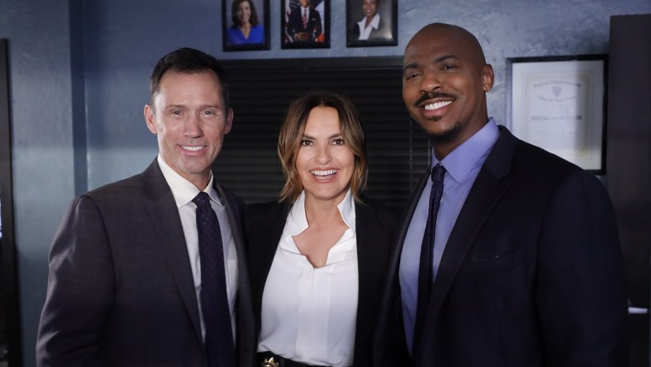

## [‘Law & Order’ premiere event brings 3 casts together for first time](https://www.today.com/video/-law-order-premiere-event-brings-3-casts-together-for-first-time-146878021828)

Brooks has loved working with his "Law & Order" co-stars and called Donovan his "brother from another mother."

"He's amazing, my unofficial mentor. He doesn't know that," Brooks said, before adding Donovan is "one of the most thoughtful actors" he's ever worked with.

"He's so meticulous. He just knows how to approach a scene from every angle."

Brooks described Camryn Manheim, who portrays Lieutenant Kate Dixon, as "hilarious."

"She's an incredible actress, incredible woman," he said. "We worked together years ago on something else. So it's so wonderful being around her again. We have great conversations."

*Don't miss Shaw's first lead homicide case when "Law & Order" returns Sept. 22 at a special time, 10 p.m., after “Law & Order: Organized Crime,” also at a special time, 8 p.m., and "Law & Order: SVU" at 9 p.m.*